
27, Shubham industrial Estate, Nr. Torrent Power Substation, S.P. Ring Road, Kathwada G.I.D.C., Ahmadabad - 382415 GST NO:-:24ARDPD2565K1ZX

info@torqpackagingsolution.com
www.torqpackagingsolution.com

Date :- 29/01/24.
To.
M/S : FASOREL,
MOZAMBIQUE.

Sub: - Automatic Inner capping and Outer capping Machine
Dear Sir,
Many thanks for your valuable inquiry of above subject. TORQ PACKAGING Solutions Is engage in making preliminary Bottle Packaging machines like bottle filling , capping , labeling, Automation, etc… in Ahmedabad, We are having dedicated team for manufacturing, customized machine development, Sales, servicing and back office.

Thanks & Regards
SHIVANGI PATEL
+91 90161 38734

Automatic Single Head Linear Inner cap and Outer Capping Machine
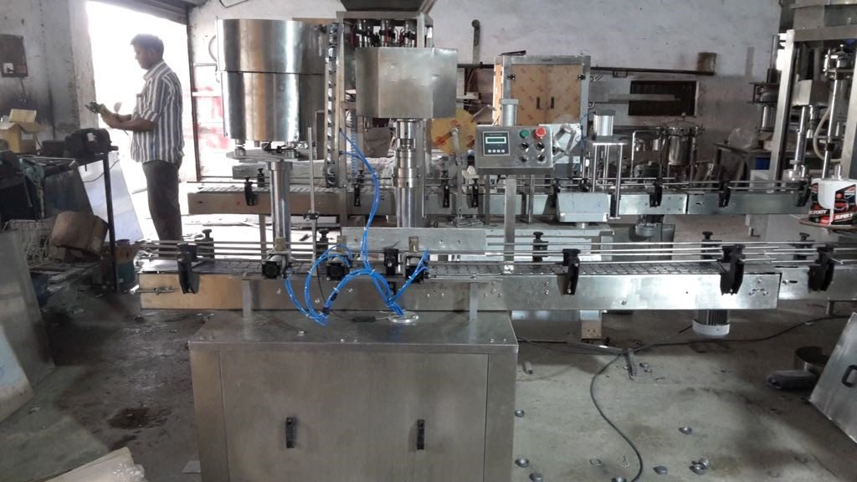

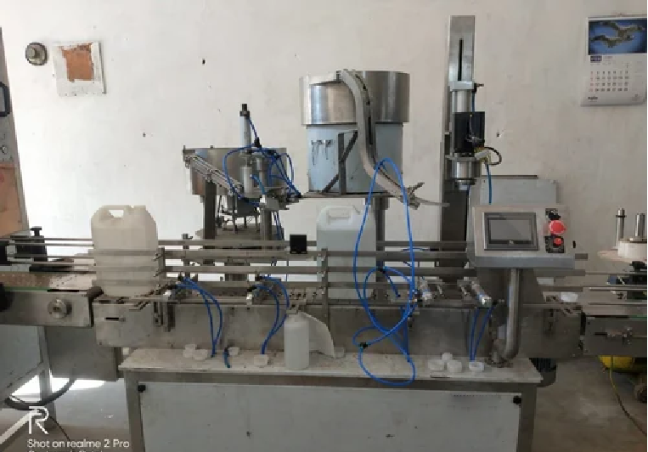

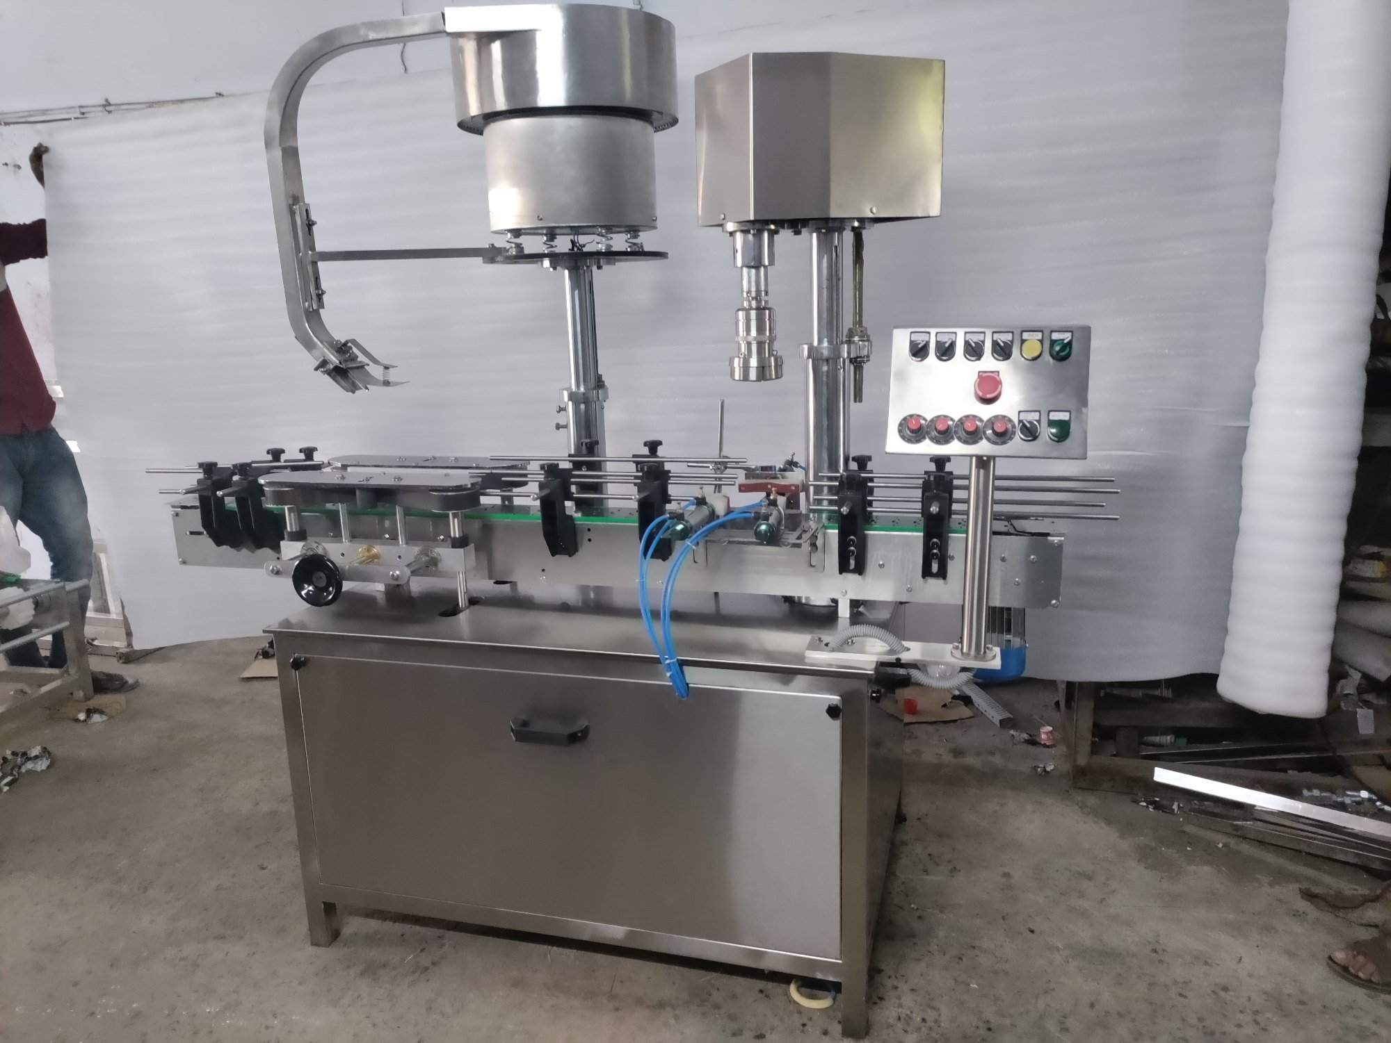
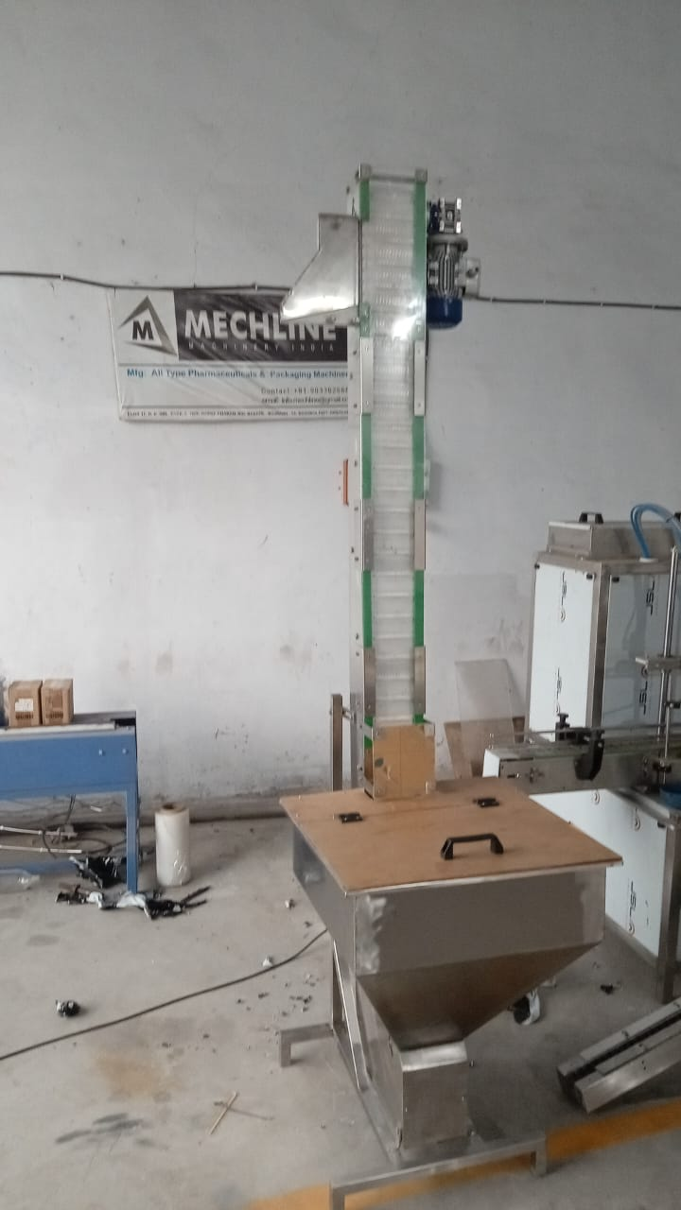
Description
Automatic inner cap pressing and outer capping machine is versatile, self-supported on stainless steel leg with height adjustable adjustment system. The machine is precision built on sturdy welded steel frame completely enclose in stainless steel sheet and doors are provided to facilitate the servicing of machine

Operation
The feed container moving on conveyor belt controlled by pneumatic cyilder,while the bottle pick up a cap from the delivery chute of cap feeding bowl, where the body and the neck of the container are positioned below the rotating head, where the pnumetic sylinder place the inner cap into the container and after placing inner will be press by next station for pressing.
Next station for the cap placement to the neck and sealing head is performing perfect operation of capping. Where the cap will be come through the suite followed by the elevator.
Technical Specifications
Output/Hour* |  |  |  |  | 15 to 20 Containers / Min
Direction of Movement |  |  |  |  | Left to Right(as per customer requirement right to left)
No of pressing head |  |  |  |  | 1 Nos.
No. of Sealing Head |  |  |  |  | 1 nos
Pneumatic cylinder |  |  |  |  | Janatics
Frl |  |  |  |  | Janatics
Solenoid valve |  |  |  |  | 230 v janatics make
Plc and HMI |  |  |  |  | Delta or equivalent (panasonic/schinder/invt)
Power Consumption | Main Motor |  |  |  | 1 HP / 415 Volts / 50 Hz.
 | Cap Feeding Bowl |  |  |  | 300 watt, Magnetic coil
Height of Conveyor |  |  |  |  | 860 mm to 910 mm
Machine Dimensions** |  |  |  |  | 3050 mm (L) x 800 mm (W) x 1850 (H) Approx.
Case Dimensions |  |  |  |  | 3200 mm (L) x 1100 mm (W) x 2000 (H) Approx.
Net Weight |  |  |  |  | 350 Kgs. Approx.
Gross Weight |  |  |  |  | 600 kgs.
Change parts required |  |  |  |  | (A) Cap Die, Delivery Chute, Bowl
Cap elevator
Hopper capacity |  |  |  | 100 ltr
Motor |  |  |  | 3 ph 0.5 hp geared motor.
sensor |  |  |  | For auto cutoff
Hight |  |  |  | 8 ft(adjustable)
Belt |  |  |  | Pvc food grade
Drive |  |  |  | Delta 1 phase
Input Specification
Screw Cap  Specification |  | Diameter** |  |  | 30 to 50 mm***
 |  | Height** |  |  | 25 to 28 mm
* Depends on bottle size, cap size and type of cap.
** We can supply as per customer requirements.
*** With help of change parts.
Salient Features
- No container No cap arrangement.
- No Change parts required for container change
- All operations are Pneumatic.
- SS elegantly matt finished body.
- Adjustable height of conveyor belt, to align with other machine of the line.
- Sealing pressure can be varied to suit different gauges and size of caps.
- Low noise level, low power consumptions.
- Self-lubricating UHMW-PE guide profile for low friction wears surface, smooth and noiseless conveying.
- SS cladding or hard chrome plating of all exposed parts to ensure long life and resistance against corrosion.
- Adjustable bottle height gauge for easy and quick setting.
Utility Requirement
Electrical supply |  |  | 1 Phase + Neutral + Earthing
Electrical load |  |  | 0.75 KW
Air pressure |  |  | 6 kg required

Price Break up
S.N. | PARTICULERS | CAPACITY | QTY | AMOUNT USD.
1 | Automatic linear inner & outer capping machine with conveyor.  Vibrator bowl for inner cap  Elevator for outer cap  10 ft conveyor | 100 ml to 5ltr | 1 | 7,218/-
2 | Automatic linear inner & outer capping machine without conveyor | 100 ml to 5ltr | 1 | 6,616/-
 | BANK DETAIL:  Account name :- TORQ PACKAGING SOLUTION  Account number:- 8000032128  Bank name :- KOTAK MAHINDRA BANK LTD  Branch :- KATHWADA  IFSC :-KKBK0002606  COMPANY GSTIN:24ARDPD2565K1ZX | TOTAL
 |  | CGST@9%
 |  | SGST@9%
 |  | IGST@18%
FOB PRIC(AHMEDABAD)
TERMS&CONDITIONS |  | For, TORQ Packaging Solution
- 60% Advance on Signing up of Contract
- 40% On Completion of Machinery Manufacturing Before Dispatch/During Inspection of machinery
- Order Once Placed Cannot be Cancelled.
- No Refund will be entertained

Required change parts for machine USD
Vibrator bowl (not required if cap size same) | 1 | 421/-
Capping suit (not required if cap size same) | 1 | 145/-
Capping head (not required if cap size same) | 1 | 121/-

- Terms & Conditions

1 | PRICE | The prices mentioned are ex our Ahmadabad works
2 | TAXES & DUTIES | 18% extra (Not required for export)
3 | TERMS OF PAYMENT | We agreed to have 60% advance and 40 % before Dispatch.
4 | DELIVERY  PERIOD | Within 3-4 Weeks from the date of receipt of technically & commercially clear order along with advance payment or receipt of approval for input dimensions, whichever is later
5 | INSURANCE | Transit Insurance against Theft, Pilferage, Breakage, Etc. will be arranged at extra cost at your explicit instruction, otherwise it will be assumed that goods are to be sent at your risk. Cost of such insurance will be as actual to be borne by the consignee.
6 | TRANSPORT | Transportation of the machine from our factory has to be arranged by you. We will arrange for loading of the equipment at our factory. However unloading at site has to be arranged by you. Our responsibility ceases once the goods leave our factory and are handed over to carrier. We do not undertake any liability for damage/ loss in transit whatsoever, whether the goods are insured or not. In case of any damage / accident during transit, the client has to directly deal with the insurance company without holding any payments, irrespective of the insurance arranged by Consigner or Consignee.
7 | INSPECTION | We offer inspection of the machine at our factory, by your technically competent representative, prior to dispatch. This person should be present on our factory during packing and loading of the machine. In case you are not deputing anyone for pre dispatch inspection, then we will not entertain any dispute arising out of short supply, quality, workmanship, functionality, operating parameter, etc. once the machine is dispatched.
8 | FACTORY  TRAINING | We will impart training to your operating staff in our factory before the machine is dispatched, at no additional cost. However, his lodging-boarding and local traveling expenses will have to be borne by you. This person should be technically competent to uncrate and assemble the machine at site before the arrival of our commissioning engineers. He must ensure that ground work necessary at site is competed in all respects before machine. Commissioning, He must be competent enough to be able to run the machine and carry out routine maintenance, once the machine is handed over after commissioning
9 | INSTALLATION | The machine has to be uncarted and placed in working position by you at site. You have to carry out all the external powers and air compressor at site. The machine must be available in the fully assembled condition when our commissioning engineer arrives at site.
10 | COMMISSIONING | For supervising and commissioning of the machine we will depute one of our engineers on chargeable bases. Customer will have to send a prior intimation of readiness of electrical and utility connections along with required materials.
11 | SPECIFICATION | In line with our policy of continual improvements, we reserve The right to modify the design and change the specifications and make of any material, if in our opinion such modification leads to an improvement in the performance of the machine. Therefore specification, illustrations, dimensions, offers, drawings or photographs are not binding in detail.
12 | WARRANTY | Our goods carry a warranty of one-year trouble free operation from the date of dispatch. The warranty is only against manufacturing defect. It does not cover any electrical, electronic or bought out components.  Components getting normal wear and tear would be replaced at your cost.
13 | NOTE | Customer have to provide samples of bottles, caps, labels etc. along with the purchase order otherwise machine will be made as per our standard specifications, wherein we will take trial with water, caps, bottle, label etc available with us, which will be acceptable to you.
14 | CANCELLATON  OF ORDER | Order once placed, cannot be cancelled under any circumstances. In case of orders being cancelled, then the entire amount of advance payment will stand forfeited.
15 | OFFER VALIDITY | This offer remains valid for the period of 30 days. Any extension thereafter will be subject to our written confirmation only.
16 | JURISDICTION | No legal proceedings shall be taken to enforce claims and no suit arising out of any contracts shall be instituted except in a court of competent jurisdiction located within Ahmedabad, Gujarat.

